Tennis, Pickleball, and Sand Volleyball Reservation Instructions

1. Visit [www.lakewood.org/register](http://www.lakewood.org/register) and the following page will appear:

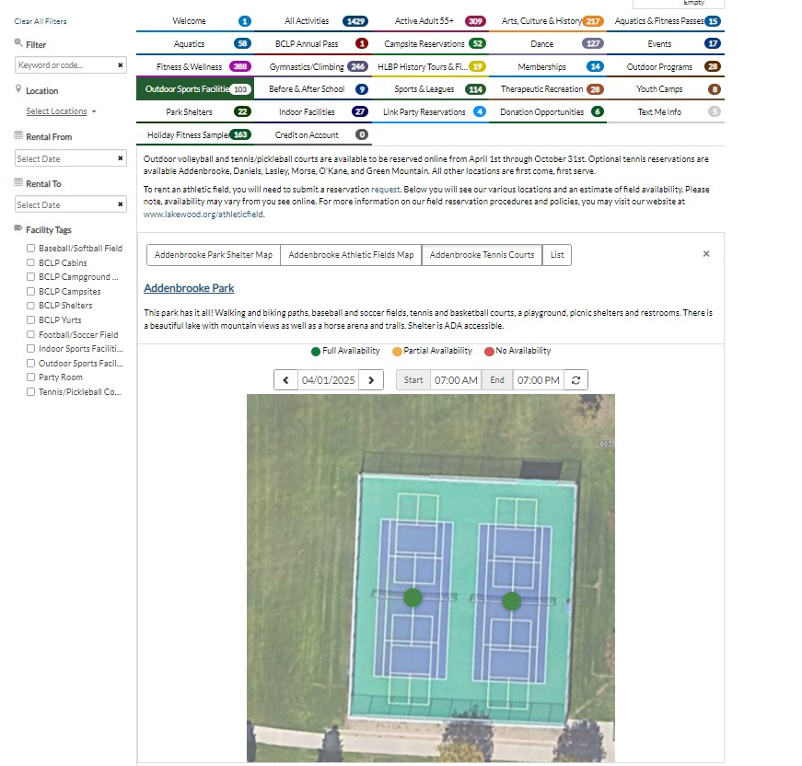

1. Click on the Outdoor Sports Facilities tab as highlighted in the above picture. Addenbrooke #2 is being used as an example but you can select any of our parks that allow online reservations.
2. Enter the date, start time, and end time and hit the refresh button next to the end time. If the circle over the court is still green, it should be available.

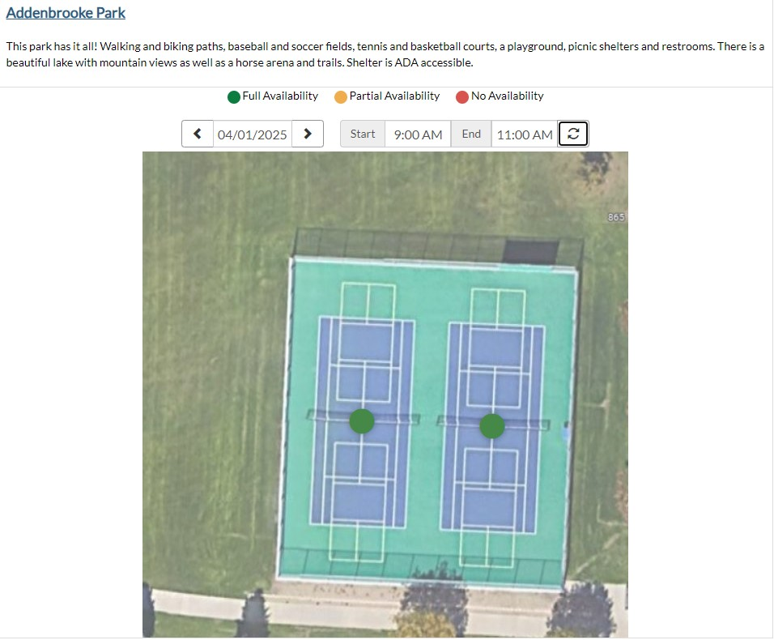

1. Click on the green dot and re-enter the date and time you would like and add to your cart. Please be sure to select the correct rate based on residency of Lakewood.

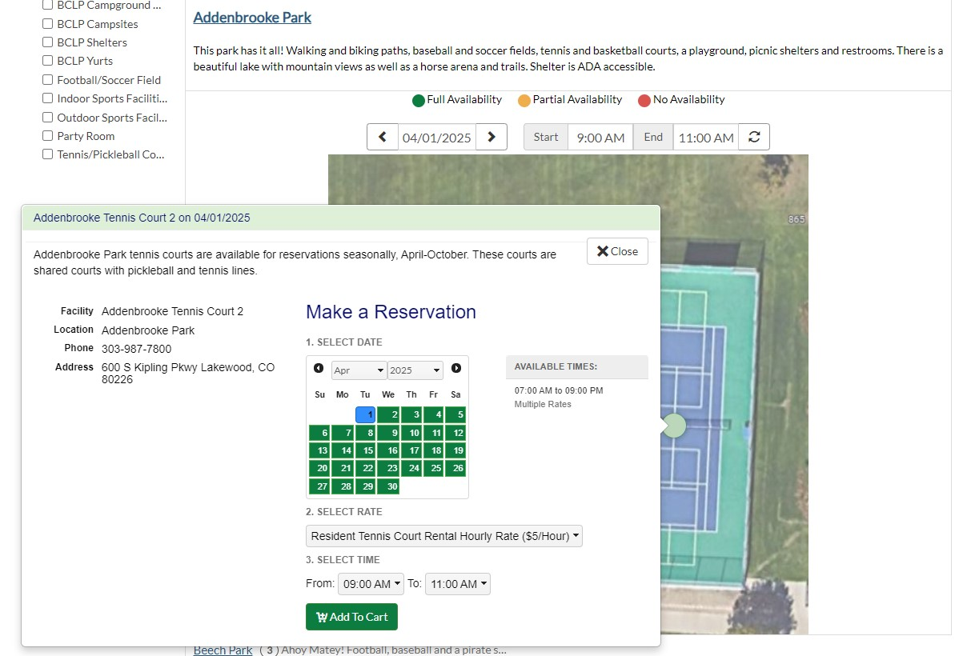

1. 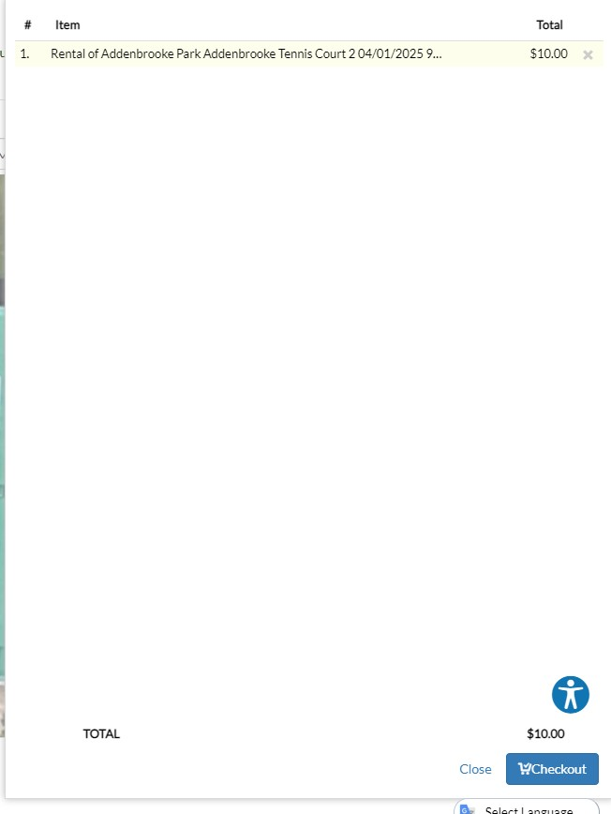 Click “Cart” on the upper right of the screen and click on “Checkout” on the bottom right of the popup.
2. 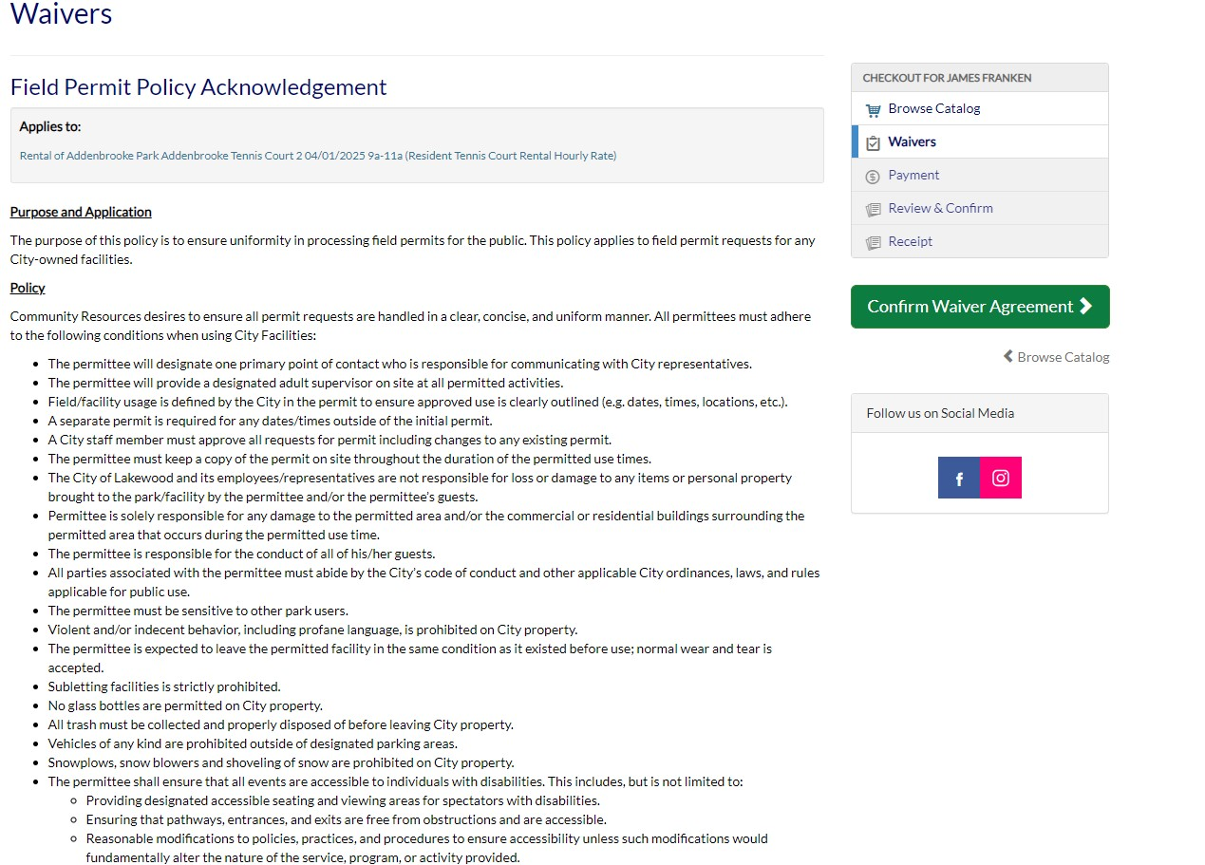Carefully read through the policies and waiver information and sign at the bottom of the screen if you agree. Then click “Confirm Waiver Agreement”.
3. 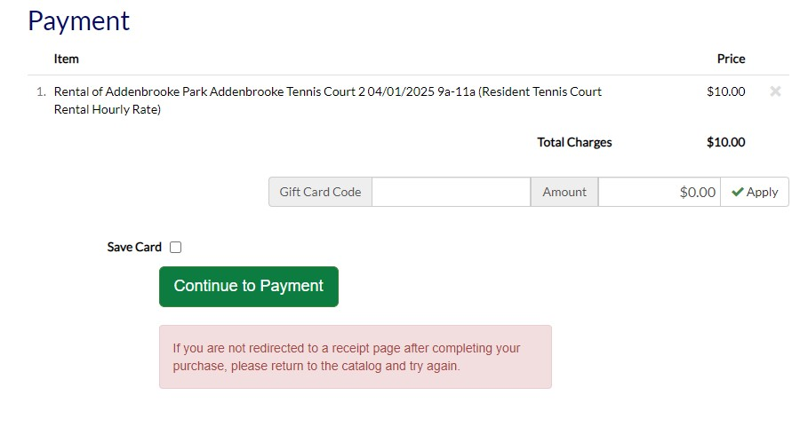Click on “Continue to Payment” and enter all relevant information on the following screen.

Your reservation is complete once payment is complete and you receive your receipt. You will also receive a permit with the date, time, and location of your reservation. This permit gives you exclusive use of the space at that location for the duration of the reservation.

Reservations will be completed in the same manner for all tennis, pickleball, or sand volleyball courts at any location that has reservable courts.

To reserve pickleball, reserve only **one** shared tennis court to get access to **two** pickleball courts.

If you have any questions or experience complications, please call 303-987-5407.